

**SYSTEM OVERVIEW**

*Sample Text here sample text here sample text here sample text here sample text here sample text here sample text here sample text here sample text here sample text here sample text here sample text here sample text here sample text here sample text here sample text here sample text here sample text here sample text here sample text here sample text here sample text here sample text here sample text here sample text here sample text here sample text here sample text here sample text here sample text here sample text here sample text here sample text here sample text here sample text here sample text here sample text here sample text here sample text here sample text here sample text here.*

**GENERAL INFORMATION OF SYSTEM**

*Sample Text here sample text here sample text here sample text here sample text here sample text here sample text here sample text here sample text here sample text here sample text here sample text here sample text here sample text here sample text here sample text here sample text here sample text here sample text here sample text here sample text here sample text here sample text here sample text here sample text here sample text here sample text here sample text here sample text here sample text here sample text here sample text here sample text here sample text here sample text here sample text here sample text here sample text here sample text here sample text here sample text here.*

**SYSTEM PREFACE**

*Sample Text here sample text here sample text here sample text here sample text here sample text here sample text here sample text here sample text here sample text here sample text here sample text here sample text here sample text here sample text here sample text here sample text here sample text here sample text here sample text here sample text here sample text here sample text here sample text here sample text here sample text here sample text here sample text here sample text here sample text here sample text here sample text here sample text here sample text here sample text here sample text here sample text here sample text here sample text here sample text here sample text here.*

**User Manual - Admin**

**CEU Purchasing System**

Admin Dashboard

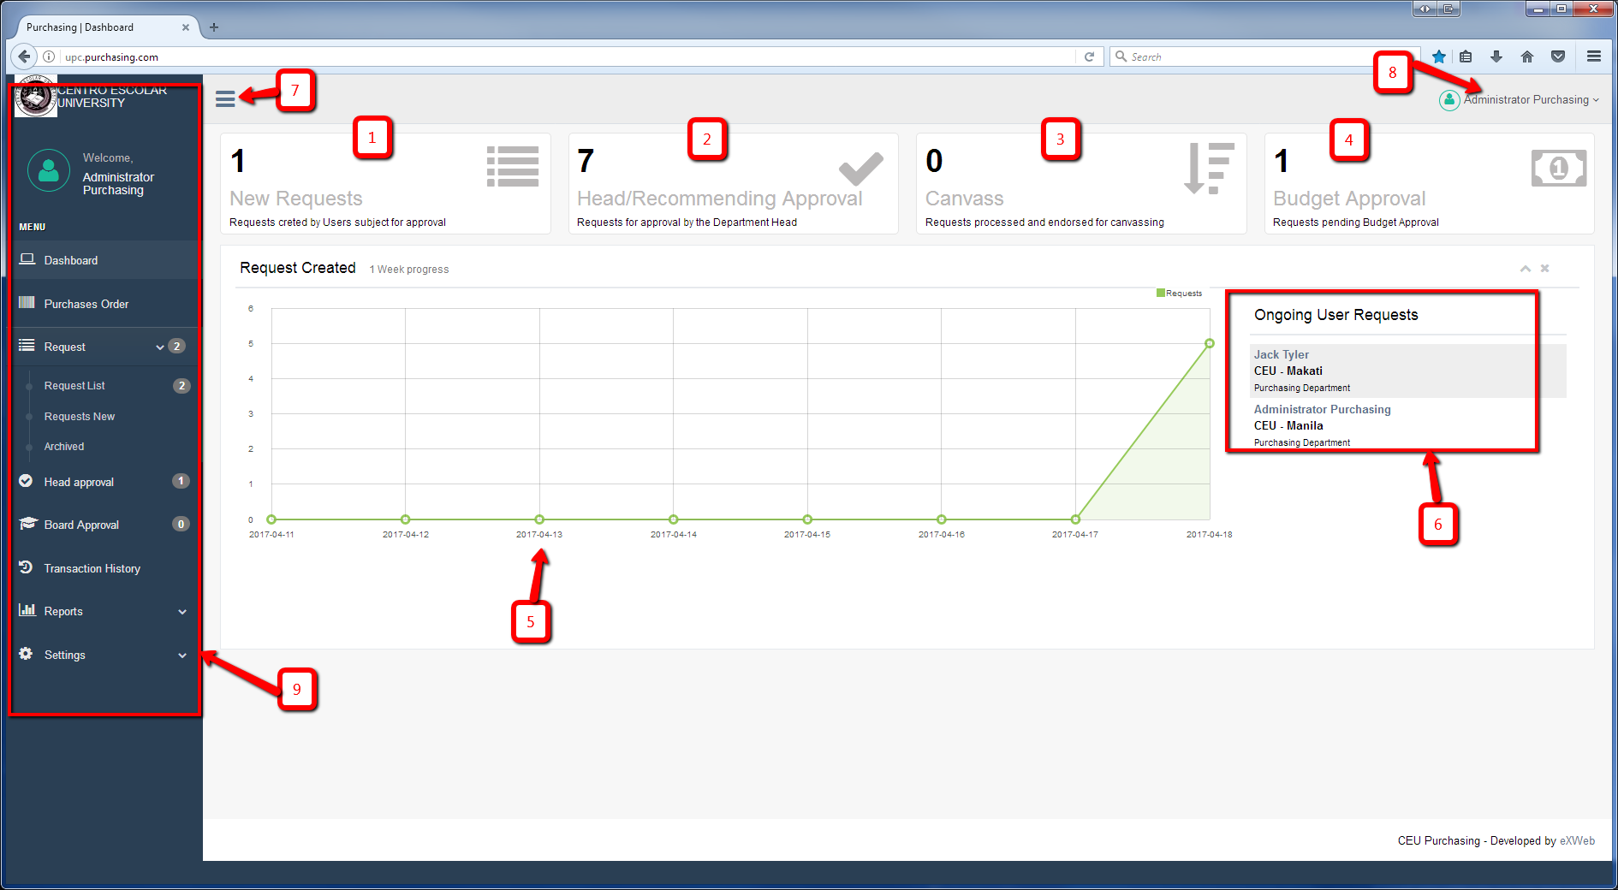Figure 1.

1. Number of newly created request.
2. Request currently in the Head/Recommending approval.
3. Request currently canvassing.
4. Request currently in the budget approval
5. Shows the graph of the request
6. Users currently have an ongoing request
7. Hide/Show side bar menu

*Figure 1.1 – Top Navigaton*

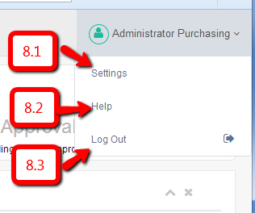

1. Top navigation – Figure 1.1
2. Side bar menu – Figure 1.2

8.1. Settings

8.2 Help

8.3 Logout

Figure 1.2 – Sidebar Menu

*Figure 1.2 – Sidebar Menu*

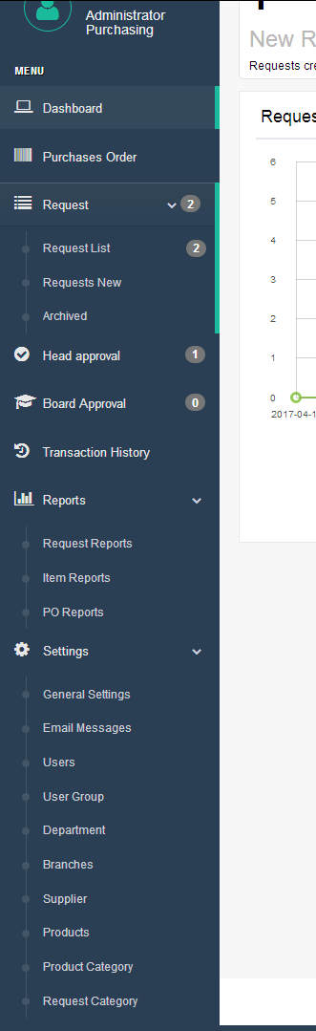

1. Dashboard
2. Purchases Order
3. Request
   1. Request List
   2. Request New
   3. Archived
4. Head Approval
5. Board Approval
6. Transaction History
7. Reports
   1. Request Reports
   2. Item Reports
   3. PO Reports
8. Settings
   1. General Settings
   2. Email Messages
   3. Users
   4. User Group/User Type
   5. Department
   6. Branches
   7. Supplier
   8. Products
   9. Product Category
   10. Request Category

Note: There you can see the number at the right side of the menu. That means that you have a number of tasks for that menu and you need to take action. Also note the every list or table of that page where you can see the green row, that means that you need to take action on that row. See figure 4.0 for the green row.

**Setting up the system**

Before anything else, you need to setup all the settings of the system so you need to go to the settings menu. *See figure 1.2. You need to add first Department and Branches settings before adding a user’s. You also need to add the product Category before adding the Products.*

**General Settings**

General settings page where you can set the Company Profile, Purchase Order, and the Dashboard.

**Email Messages**

The Email Messages page where you can set the content of the emails on every process. Once you click the “Edit” button, there you can see the content of the email on that process. Please fill up the “Subject” and the “Message” Content. There are default emails that has been stored but you can edit those. There are shortcodes that you need know to make it dynamic. See shortcodes below.

Shortcodes

* [name_from] – This will replace to the name of the user where the process came from.
* [email_from] – This will replace to the email of the user where the process came from.
* [name_to] – This will replace to the name of the user whom the process to come.
* [email_to] – This will replace to the email of the user whom the process to come.
* [request_number] – This will replace the request number.
* [request_name] – This will replace by the name of the request.
* [urgency_level] – This will replace by the priority label of the request
* [message] – This will replace by the message of the sender.
* [po_num] – This will replace by the purchase order number.
* [item_name] – This will replace by the product name or item name.

**Users**

Users page where you can add, edit, deactivate and change the password of the users. Before adding a user, please make sure that the Branch and The Department is already setup.

* **User Type**: There are 8 kind of user type on this system enumerated below.
  + **Administrator** – The administrator of this system which have the main user doing this purchasing process.
  + **General User** – The User or the employee of the company.
  + **Canvasser** – The canvasser is the person who has his role is to canvass the product or item.
  + **Budget** – The budget department is the user type who approve the budget.
  + **VP Administration and Accounting** – The role of this user is to audit the Purchase Order.
  + **Purchasing Committee** – This User type has no role on this system, we just need to register a person on this user type for the email purposes to approve the huge amount of budget.
  + **Board** – Board department is just like the Purchasing Committee however it only notify if the budget is larger than what’s the purchasing committee can handle.
  + **Property Department** – This User type is the one who handle the inventory of the products or item.
* **Branch** – Select which branch the user belongs to.
* **Department** – Select which department the user belongs to.
* **Department Head** – Only check this checkbox option if the user you want to add is the head of its department.
* **First name** – First name of the person or user.
* **Last Name** – The Last name of the person or user.
* **Phone** – Contact number of the user
* **Email** – Email address of the user.
* **Password** – Enter the desired password you want the user to use. You need to click the “**activate”** button after you add the user. However, user can also defined there own password because after you add the user, there will be an email confirmation for the user where they can input a new password for their own.

**User Group**

User group has only fixed 8 user type. You can only edit the description on this page. The description will appear when you add or edit the user as “User Type”.

**Department**

This page where you can add, edit and delete the User department. This will also appear when you add a user so this need to setup first before adding the user.

**Branches**

This page where you can add, edit and delete the branches of the company. This will appear also when you add a user where you can select which branch they are. This will need to setup first before adding a users.

**Supplier**

This page where you can add, edit and delete the supplier. The supplier will appear in the canvasser page where they can select the supplier they have canvassed. Canvasser can also put a supplier that is not added here.

**Products**

Admin can also add the common products here so that the requisitioner can only select the product they want to request. If the products is not exists, they can also put a custom product.

**Product Category**

Admin can add a product category on this page. The category has only have a second level. This will also setup first before adding a product because this will appear when you add a products.

**Request Category**

Request category is for admin purpose. Admin can select which category is the request belongs to. These will appear when the admin assign the request to canvasser.

**Purchase Order**

* You can see in this page all the generated purchase order. The “Update” button will be disabled once it is already approved by the VP Administration and Accounting.

**Request**

1. Request List – You can find all the request of the users here. You can view the items of the request by clicking the “View Items” button and if you want to go to the details of the request, just click the link in the request name. The buttons under “Action” button will be different depends on the current status of the request.
2. Request New – This menu is the step where you can request.
3. Archived – This page where you can see all the archived request. All the archived request are already done in the process.

**Head Approval**

* This menu or page will appear only if you have assigned by the admin as a head of the department. There you can see the newly requested by your staff or even other department staff if it is assigned to you as a recommending approval.
* The buttons under “Action” button will be different depends on the current status of the request.
* Click the “View Items” button to view the items that is assigned to you. See figure 3.1. You can also see the items that is assigned to the other head (see *Assigned To* column). You can approve and deny only the item assigned to you. When you deny, it will notify the requisitioner. Once the requisitioner will response, it will appear the response to the *Requisitioner Note* column. All the items should be approved by all the recommending officer before it will be forwarded to the admin.

**Board Approval**

* This page where you can see all the request that is greater than 250k. Your action whether you approve it or not.

**Transaction History**

* There you can see all the transaction records of the request.

**Reports**

* You can find here all the reports.

1. Request Reports – It will show all the Request Reports. There are different filter like Campus, Department, Year, Month and School Year. You can print it as PDF, Excel or print it directly.
2. Item Reports – It will show you all the items requested. There are different filter like Campus, Department, Year, Month and School Year. You can print it as PDF, Excel or print it directly.
3. PO Reports – It will show you all the Purchase Order records. There are different filter like Campus, Department, Year, Month and School Year. You can print it as PDF, Excel or print it directly.